## **Playing files directly from a SD Card**

1. Insert your microSD card to the side of the unit
2. Use the remote to navigate to the **SD card** menu
3. Navigate through your SD cards directory to locate your video files
4. Play them by selecting them.

## **Adding files to the network storage**

1. Insert your microSD card to the bottom of the unit
2. Use the remote to navigate to the **SD card** menu
3. Press and **briefly hold** the “i” button on the remote
4. You should get a message in the top right that indicates the videos are transferring
5. The files will be added to the **Unsorted_Videos** folder on the network storage within a folder whose name matches the name of your SD card and the date that it was uploaded.

## **Viewing files on the network storage**

1. Scan the below QR code to view all files on the network storage.
2. Any newly added files will be added to the **Unsorted_Videos** folder on the network storage within a folder whose name matches the name of your SD card and the date that it was uploaded.  
   NOTE: It is recommended to download files which may take a long time

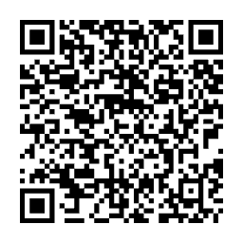

**https://drop.ui.com/ba719798-ea5b-4542-bce0-6433e50ee111**